* **Name of the Activity**: Two Day International Seminar on " In Search of Roots: Partition in History and Literature"
* **Date of the Activity**: 21.09.2022, 22.09.2022
* **Speakers:** 
  + Prof. Himadri Lahiri, Dept. of English, NSOU
  + Dr. Prajit Kumar Palit, Professor and Director, Center for Indological Studies, Dept. of History, Assam University
  + Dr. Gautam Karmakar, NRF, Post Doctoral Fellow, University of Western Café South Africa
  + Dr. Rupkumar Barman, Professor of Dept. of History, Jadavpur University
  + Dr. Attrayee Siddhanta, Assistant Professor of Bengali, Indus Mahavidyalaya,
  + Dr. Ruporshi Chatterjee, Associate Professor of History, Galsi Mahavidyalaya.
* **Organizing Department:** Dept. of English and Dept. of History, Chakdaha College
* **Number of Participants:** 77
* **Outcome:**

A two-day international seminar was jointly organized by the Department of English and Department of History, Chakdaha College on 21st and 22nd September 2022, Dr. Swagata DasMohanta, Principal, chakdaha college was the patron and chairperson in the said seminar. She had welcomed the distinguished speakers. Professor Palit in his talk focused on partition and the issue of communalism. Professor Barman elaborately discussed partition and minority issues whereas Dr. Karmakar emphasized on representation of partition and related issues in cinema. Paper presenters also focused on various aspect of partition. Honours students of both of the departments were largely benefited by the interesting and intriguing discussion of the seminar.

* **Brochure:**

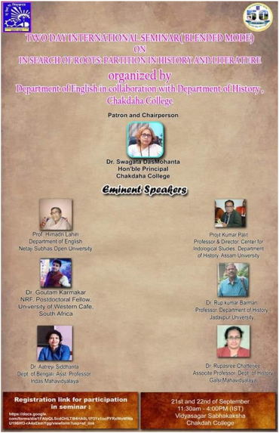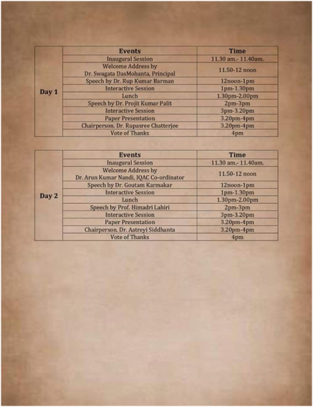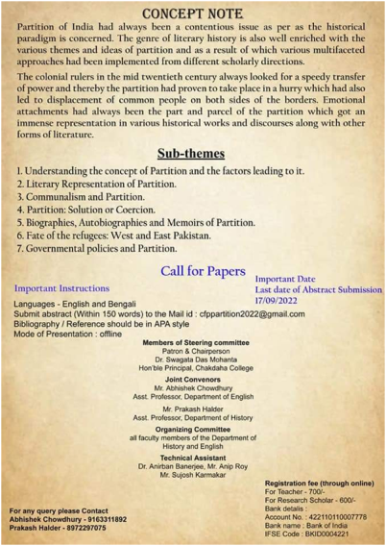

* Photographs of the Seminar:

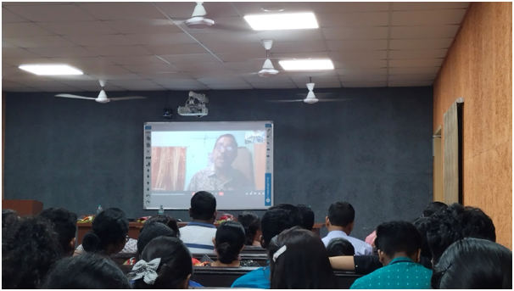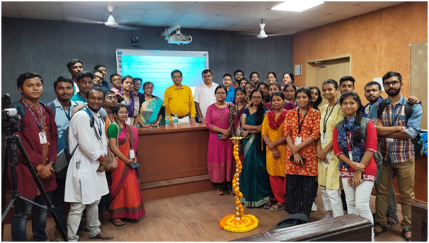

Registration list for Teacher and Research Scholar:

|  |  |  |  |  |  |  |  |  |
| --- | --- | --- | --- | --- | --- | --- | --- | --- |
| S.L | | Name | Designation | | College | | Mobile No | |
| 1 | | Probin Biswas | Asst.Prof | | S.R.L Mahavidyalaya | | 8250203577 | |
| 2 | | Fulandebi Mandal | Student | | V.B.U | | 7602730783 | |
| 3 | | Sumit Ghosh | Asst.Prof | | S.R.F College | | 7908008925 | |
| 4 | | Sahajahan Zamader | Asst.Prof | | Sonamukhi College | | 6295032402 | |
| 5 | | Ayan Kumar Maity | Research Scholar | | Seekom skill university | | 9433167163 | |
| 6 | | Dr.Bipul Mandal | Asst.Prof | | Ranaghat College | | 9830162589 | |
| 7 | | Dr.Sujit Bala | Asst.Prof | | Raghunathpur College | | 801777 | |
| 8 | | Mallika Bala | PhD.Scholar | | IIEST Shibpur | | 62979 | |
| 9 | | Arudev Mazumder | PhD.Scholar | |  | | 9734826490 | |
| 10 | | Dr.Sandip Biswas | Asst.Prof | | Maharraja Siris Chandra College | | 6289544916 | |
| 11 | | Dr.Sumit Kumar Mandal | Asst.Prof | | Gobinda Prasad Mahavidyalaya | | 9153525544 | |
| 12 | | Dinesh Das | Asst.Prof | | Asannagar mmt college | | 8575933620 | |
| 13 | | Bidyut Sarkar | Asst.Prof | | Maharraja Siris Chandra College | | 6290880934 | |
| 14 | Swagata Roy | | | Ex-student | | Chakdaha College | | 8944847016 | |
| 15 | Abhishek Choudhury | | | Asst.Prof | | Chakdaha College | | 9163311892 | |
| 16 | Prakash Halder | | | Asst.Prof | | Chakdaha College | | 8972297075 | |
| 17 | Palash Biawas | | | SACT | | Chakdaha College | | 8653315941 | |
| 18 | Pali Dey | | | SACT | | Chakdaha College | | 9333870605 | |
| 19 | Sonali Kar | | | SACT | | Chakdaha College | | 9378081673 | |
| 20 |  | | | SACT | | Chakdaha College | | 9635492727 | |
| 21 | Praksh | | | SACT | | Chakdaha College | | 9046963588 | |
| 22 | Dr.Sudeshna Barin | | | SACT | | Chakdaha College | | 9748555132 | |
| 23 | Firoj Mandal | | | SACT | | Chakdaha College | | 8942936404 | |
| 24 | Meghamitra Dey | | | SACT | | Chakdaha College | | 7001438297 | |
| 25 | Abesh | | | SACT | | Chakdaha College | | 8974089343 | |
| 26 | Sagata Bhadra | | | SACT | | Chakdaha College | | 94754 | |
| 27 | Abijit Biswas | | | SACT | | Chakdaha College | | 9932276219 | |
| 28 | Moumita Ghosh | | | SACT | | Chakdaha College | | 9804426149 | |
| 29 | Ahana Bh | | | SACT | | Chakdaha College | | 8902561143 | |

Registration list for Students (21 & 22 September)

|  |  |  |  |  |
| --- | --- | --- | --- | --- |
| S.L | Name | Designation | College | Mobile No |
| 1 | Simantini Das | student | Chakdaha College | 7076467878 |
| 2 | Piyali Sarkar | student | Chakdaha College | 6290466861 |
| 3 | Kana Biswas | student | Chakdaha College | 9832391729 |
| 4 | Rupa Bala | student | Chakdaha College | 9832606670 |
| 5 | Priyanka Day | Student | Chakdaha College | 9332114120 |
| 6 | Sohini Bhattacharya | student | Chakdaha College | 9038997328 |
| 7 | Koustav Dutta | student | Chakdaha College | 8942917752 |
| 8 | Barnali Majumder | student | Chakdaha College | 7384777043 |
| 9 | Soumi Mitra | student | Chakdaha College | 7478099185 |
| 10 | Arpita Roy | student | Chakdaha College | 8670770842 |
| 11 | Amit Biswas | student | Chakdaha College | 8240886558 |
| 12 | Sajib Pandey | student | Chakdaha College | 8945028999 |
| 13 | Ayon Roy | student | Chakdaha College | 7980732596 |
| 14 | Arnab Biswas | student | Chakdaha College | 8348812159 |
| 15 | Amit Barai | student | Chakdaha College | 6289568070 |
| 16 | Bristy Paul | student | Chakdaha College | 7439595190 |
| 17 | Vishnw Bala | 3rd(E.H) | Chakdaha College | 7477564665 |
| 18 | Mitu Kirtonia | 3rd(E.H) | Chakdaha College | 7029666481 |
| 19 | Sneha Biswas | 3rd(E.H) | Chakdaha College | 6294251243 |
| 20 | Saibal Ghosh | 3rd(H.H) | Chakdaha College | 9842980089 |
| 21 | Swapnanil Gangopadhyay | 3rd(H.H) | Chakdaha College | 7797414067 |
| 22 | Subhankar Chakraborty | 3rd(H.H) | Chakdaha College | 9547966804 |
| 23 | Susmita Majumder | 3rd(H.H) | Chakdaha College | 6297441285 |
| 24 | Julia Sautara | 3rd(E.H) | Chakdaha College | 9393273072 |
| 25 | Bhaswate De | 3rd(E.H) | Chakdaha College | 6296280515 |
| 26 | Suman Debnath | 3rd(E.H) | Chakdaha College | 98327960 |
| 27 | Himdari Das | 3rd(E.H) | Chakdaha College | 9875568604 |
| 28 | Dipayan Ghosh | 3rd(E.H) | Chakdaha College | 8101765526 |
| 29 | Sagar Sen | 3rd(H.H) | Chakdaha College | 8509950918 |
| 30 | Mamani Pal | 5th(H.H) | Chakdaha College | 9333323011 |
| 31 | Anindita Ukil | 5th(H.H) | Chakdaha College | 9883321627 |
| 32 | Ankita Ghosh | 5th(H.H) | Chakdaha College | 9339568313 |
| 33 | Disha Sarkar | 5th(H.H) | Chakdaha College | 9330033941 |
| 34 | Debasish Dutta | 5th(H.H) | Chakdaha College | 6295385575 |
| 35 | Bedesha Uhan | 5th(H.H) | Chakdaha College | 8617818989 |
| 36 | Ananya Gosh | 5th(Eng Hons) | Chakdaha College | 6289247193 |
| 37 | Bipasna Pramanik | 5th (English) | Chakdaha College | 7980503963 |
| 38 | Dipti Biswas | 6th (Eng Hons) | Chakdaha College | 8101904860 |
| 39 | Sarbani Bala | 5th (History) | Chakdaha College | 9832829502 |
| 40 | Purbasha Ghosh | 5th (History) | Chakdaha College | 9883978035 |
| 41 | Sebika Roy | 3rd (English) | Chakdaha College | 9749004748 |
| 42 | Mallika Bala | PhD scholar | Chakdaha College | 6297979152 |

22nd September 2022

|  |  |  |  |  |
| --- | --- | --- | --- | --- |
| 46 | Debasish Dutta | 5th (H.H) | Chakdaha College | 6295385575 |
| 47 | Sohini Bhattacharya | 5th (E.H) | Chakdaha College | 9038997328 |
| 48 | Bhaswate De | 3rd(E.H) | Chakdaha College | 6296280515 |
| 49 | Soumi Mitra | 5th (E.H) | Chakdaha College | 7478099185 |
| 50 | Barnali Majumder | 5th (E.H) | Chakdaha College | 7384777043 |
| 51 | Arpita Roy | 5th (E.H) | Chakdaha College | 8670770842 |
| 52 | Bristy Paul | 5th (E.H) | Chakdaha College | 7439595190 |
| 53 | Dipti Biswas | 5th (E.H) | Chakdaha College | 8101904860 |
| 54 | Saibal Ghosh | 3rd (H.H) | Chakdaha College | 9842980089 |
| 55 | Amit Barai | 5th (E.H) | Chakdaha College | 6289568070 |
| 56 | Susmita Majumder | 3rd (H.H) | Chakdaha College | 6297441285 |
| 57 | SubhankarChakraborty | 3rd (H.H) | Chakdaha College | 9547966804 |
| 58 | Santanu Kundu | 3rd (H.H) | Chakdaha College | 8101076324 |
| 59 | Swapnanil Gangopadhyay | 3rd (H.H) | Chakdaha College | 7797414067 |
| 60 | Koustav Dutta | 5th (E.H) | Chakdaha College | 8942917752 |
| 61 | Simantini Das | 5th (H.H) | Chakdaha College | 7076467878 |
| 62 | Rupa Bala | 5th (H.H) | Chakdaha College | 9832606670 |
| 63 | Purbasha Ghosh | 5th (H.H) | Chakdaha College | 9883978035 |
| 64 | Sarbani Bala | 5th (H.H) | Chakdaha College | 9832829502 |
| 65 | Ayon Roy | 5th (H.H) | Chakdaha College | 7980732596 |
| 66 | Amit Biswas | 5th (H.H) | Chakdaha College | 8348812159 |
| 67 | Piyali Sarkar | 5th (H.H) | Chakdaha College | 6290466861 |
| 68 | Arnab Biswas | 5th (H.H) | Chakdaha College | 8348812159 |
| 69 | Sajib Pandey | 5th (H.H) | Chakdaha College | 8945028999 |
| 70 | Bedesha Khan | 3rd (E.H) | Chakdaha College | 8617818989 |
| 71 | Kana Biswas | 5th (H.H) | Chakdaha College | 9832391729 |
| 72 | Sujay Tapader | 3rd (H.H) | Chakdaha College | 8967013829 |
| 73 | Mitu Kirtania | 3rd (E.H) | Chakdaha College | 7029646481 |
| 74 | Vishnu Bala | 3rd (H.H) | Chakdaha College | 7477564665 |
| 75 | Bristi Mallick |  | Chakdaha College | 6290389369 |
| 76 | Sanira Mondal |  | Chakdaha College | 7501783200 |
| 77 | Sneha Biswas |  | Chakdaha College | 6294251243 |

***Relevant Web Link:***

[***https://www.facebook.com/photo/?fbid=465918085548961&set=pcb.465918192215617***](https://www.facebook.com/photo/?fbid=465918085548961&set=pcb.465918192215617)